**Sakila PowerBI Oracle**

Question 1:

Film categories by rental amount (ranked) & rental quantity with a rental rate of $0.99 and a PG Rating – tabular & sql query

Select c.name as FilmCategory, sum(p.amount) as RentalAmount, count(p.rental_id) as RentalQuantity,

DENSE_RANK() over(order by sum(p.amount) desc) as CategoryRank

from payment p

inner join rental r on p.rental_id=r.rental_id

inner join inventory i on r.inventory_id=i.inventory_id

inner join film f on i.film_id=f.film_id

inner join film_category fc on f.film_id=fc.film_id

inner join CATEGORY c on fc.CATEGORY_ID=c.CATEGORY_ID

where f.rental_rate = 0.99 and f.RATING='PG'

group by c.name, f.rental_rate, f.RATING;

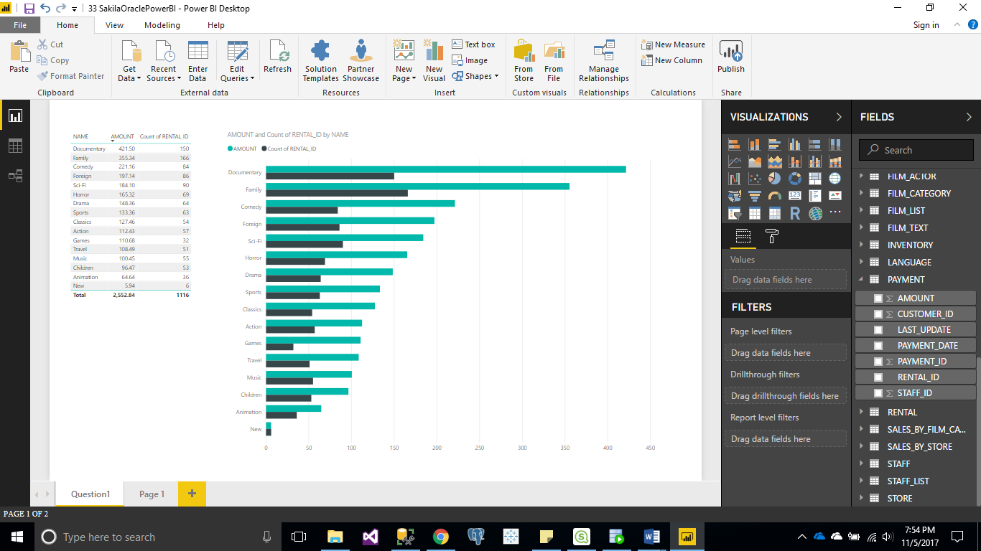

Question 2:

Contribution by rental amount for customers from France, Italy or Germany - Treemap (or Heatmap) & sql query

select CONCAT(CONCAT(cu.first_name, ' '),cu.last_name) as CustomerName, sum(p.amount) as RentalAmount

from payment p

inner join customer cu on p.customer_id=cu.CUSTOMER_ID

inner join Address ad on cu.ADDRESS_ID=ad.ADDRESS_ID

inner join City ci on ad.CITY_ID=ci.CITY_ID

inner join Country co on ci.COUNTRY_ID=co.COUNTRY_ID

where co.Country='France' or co.Country='Italy' or co.Country='Germany'

group by CONCAT(CONCAT(cu.first_name, ' '),cu.last_name)

order by sum(p.amount) desc;

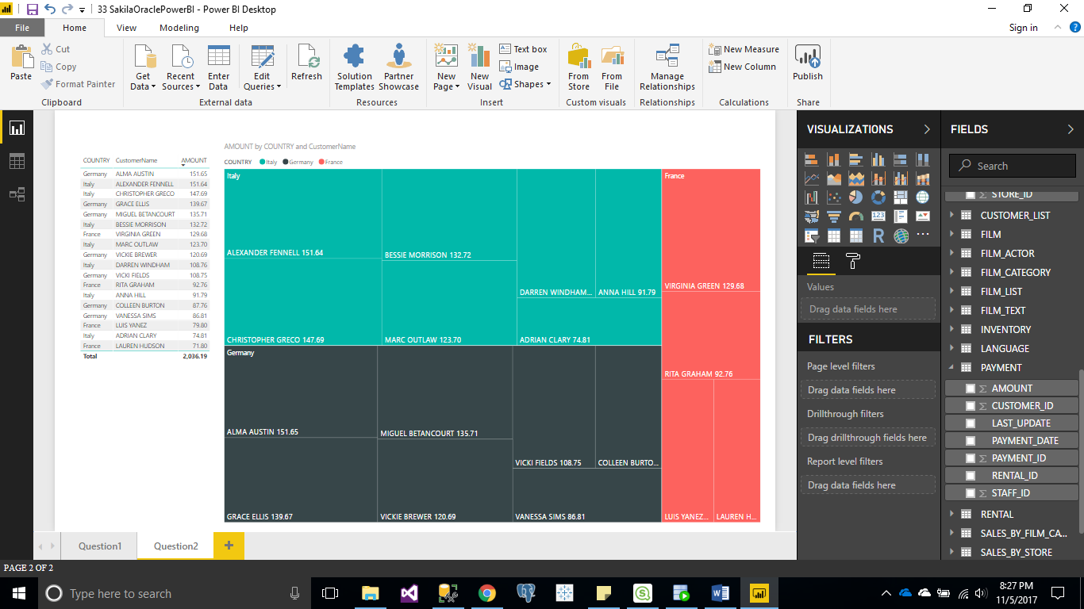

Question 3:

List top 10 Films by rental amount (ranked) with replacement cost greater than $25 – bar chart & sql query

with question3 as (Select f.title, sum(p.amount),

DENSE_RANK() over(order by sum(p.amount) desc) as FilmRank

from payment p

inner join rental r on p.rental_id=r.rental_id

inner join inventory i on r.inventory_id=i.inventory_id

inner join film f on i.film_id=f.film_id

where f.replacement_cost > 25

group by f.title

)

select * from question3 where ROWNUM <= 10;

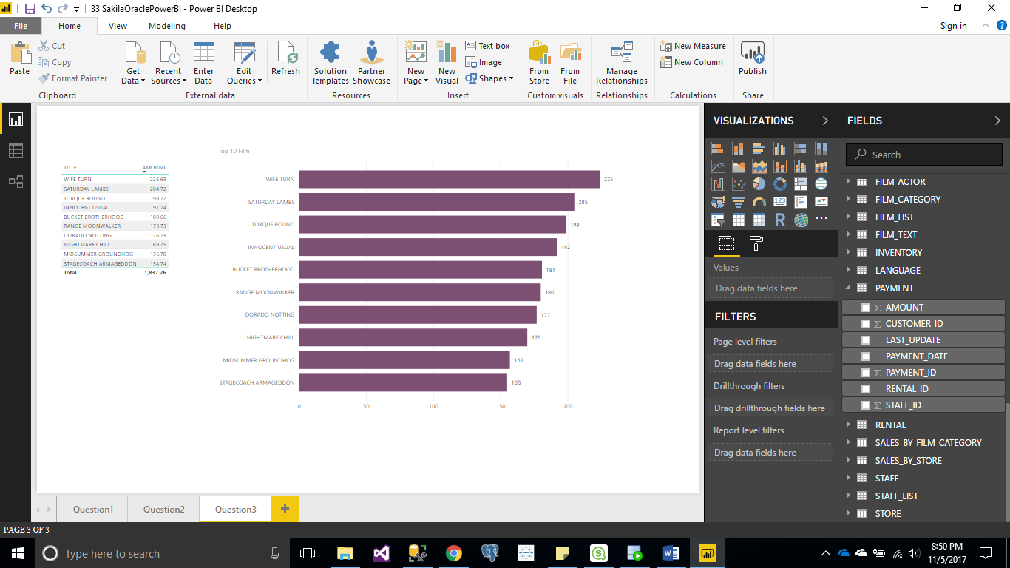

Question4:

Rental amounts by cities for R rated films - bar chart & sql query

select ci.city, sum(p.amount) as RentalAmount

from payment p

inner join customer cu on p.customer_id=cu.CUSTOMER_ID

inner join Address ad on cu.ADDRESS_ID=ad.ADDRESS_ID

inner join City ci on ad.CITY_ID=ci.CITY_ID

inner join rental r on p.rental_id=r.rental_id

inner join inventory i on r.inventory_id=i.inventory_id

inner join film f on i.film_id=f.film_id

where f.RATING='R'

group by ci.city

order by sum(p.amount) desc;

